SMALL BUSINESS RELIEF FUND

link for fund: https://www.boston.gov/departments/economic-development/small-business-relief-fund

Screenshot for link:

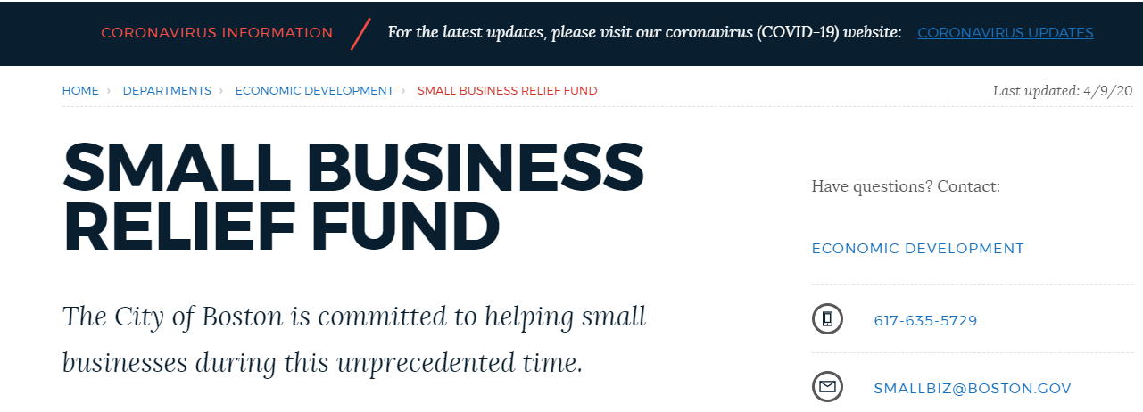
The City of Boston is committed to helping small businesses during this unprecedented time.
We have established the Small Business Financial Relief Fund to help businesses most impacted by COVID-19. We want to provide immediate help and guidance.

The Boston Planning & Development Agency recently published a report on the economic impact of COVID-19 on Boston's economy.

Before applying, be sure to gather the following information necessary to complete the application:
- Proof of a Boston business address (as indicated by a signed lease or home office documentation)
- A copy of the business’ most recent fiscal year tax return
- Proof of payroll (required for businesses with more than two (2) employees)
These documents will need to be uploaded in your application to complete submission.

APPLY TODAY!
Please review and complete the application fully:
FILL OUT THE APPLICATION Ctrl-Click to follow Link

TYPES OF GRANTS
For the purpose of this fund, a "small business" will be defined as a for-profit entity with:
- fewer than thirty-five (35) employees
- less than $1,500,000 in annual revenue, and
- registered with, in good standing with, and operating in, the City of Boston (excluding chain or corporate franchises).
Grants can be used to help address fixed debts, payroll, accounts payable, lost sales, lost opportunities, and other working capital expenses that could have been recognized had the COVID-19 pandemic not occurred.

